Information letter for participants

An Observational Study on the Effects of Psilocybin Truffle Use in a Retreat Setting

Dear potential participant,

You’re invited to join a study investigating how using psilocybin "magic" truffles at a retreat can lead to personal change and transformation. This study is being conducted by Prof. Michiel van Elk of the Cognitive Psychology unit at Leiden University and has been approved by the Psychology Research Ethics Committee of Leiden University.

Purpose of the study

This study looks at how psilocybin “magic” truffles used in a retreat setting can change aspects of your experience and mental processes, such as your sense of wellbeing, meaning in life, and mindfulness. We also want to see how the retreat setting contributes to potentially lasting changes in your experience and personality.

Participation

We are sharing this information with you because it is important that we provide you with all the required information to enable you to make an informed decision about participating in this study. Please take as long as you need to read this letter and discuss it with your friends and family.

If, after reading this information, you wish to participate in the study, please send an email to retreatESM.study@fsw.leidenuniv.nl and we will contact you by telephone or email (per your preference) within a few days. This will give you the opportunity to ask any questions you may have about the study before making your decision regarding participation. If you decide to participate in this study, we will schedule an intake meeting with you as soon as possible, which can take place online or in-person, based on your preference.

Participation in this study is completely voluntary. This means that you can end your participation at any time and without any explanation. This will not have any negative consequences for you.

If you want to end your participation in the study at any point, let us know by contacting our research team via retreatESM.study@fsw.leidenuniv.nl, or your retreat center.

For this study, we are seeking healthy volunteers who are planning to attend a truffle retreat and who can speak, read, and write in English. It is not possible to participate in the research if you are younger than 16 years or older than 80 years of age, are pregnant or nursing, or are not capable of giving informed consent.

Procedure

The study will take place online on m-Path, an online platform and smartphone app for long-term research. The whole study will be spread across a three-and-a-half-month period.

In the case of your interest in potentially participating in this study, we will schedule an in-person or online intake meeting with you. During this meeting, we will work with you to generate the personal question items that you will be answering daily. This will involve generating 15 to 20 questions belonging to several different categories such as mood, meaning in life, creativity, mind-wandering, mindfulness, quality of relationships, etc. This meeting will approximately take an hour.

Once we have generated all the daily personalized items, we will provide you with the instructions on how to download m-Path on your smartphone, set an account and join the research project as a participant. We will add all the personalized items on m-Path for your daily access. You will be required to answer daily questionnaires once a day, which will be scheduled randomly within a 5 hour time window (10:00-15:00) during the day. You will have 4 hours to answer the questions once you receive the notifications on your smartphone. Answering the daily questionnaires will take approx. 2 minutes. You will be required to answer the daily questions for 2 weeks before the planned date of your retreat experience, and for 3 months after the retreat.

Before you start answering the daily questions, you will be required to complete an intake survey which will include questions on well-being, mood, meaning in life, past psychedelic substance use, lifetime experience with meditation practices, etc. The intake survey will take approx. 25 minutes to complete.

1 to 3 days before the planned date of your retreat experience, you will be required to complete a pre-retreat experience survey, which will include questions on your intentions for the

Figure 1 - A Summary of the study procedure

experience and set and setting. The pre-retreat experience survey will take approx. 15 minutes to complete.

During your retreat attendance you will be required to answer the daily questions at a different time based on the daily schedule of your retreat for your convenience. On the day of your psychedelic ceremony at the retreat, you will not be required to answer the daily questions.

Similarly, 1-3 days after your retreat experience, you will be asked to complete the post-retreat experience survey. This survey will include several questions on different aspects of your retreat experience, and how different factors shaped your experience in your own opinion. This survey will also take approx. 15 minutes to complete.

Lastly, 3 months after your retreat, you will be asked to complete the outcome survey. This survey will include items similar to the intake survey and take approx. 25 minutes to complete. Upon the completion of the outcome survey, you will be debriefed and thanked for your participation. Please see Figure 1 above for a summary of the complete study procedure. Your total time investment will be approx. 350 minutes over 3 and half months.

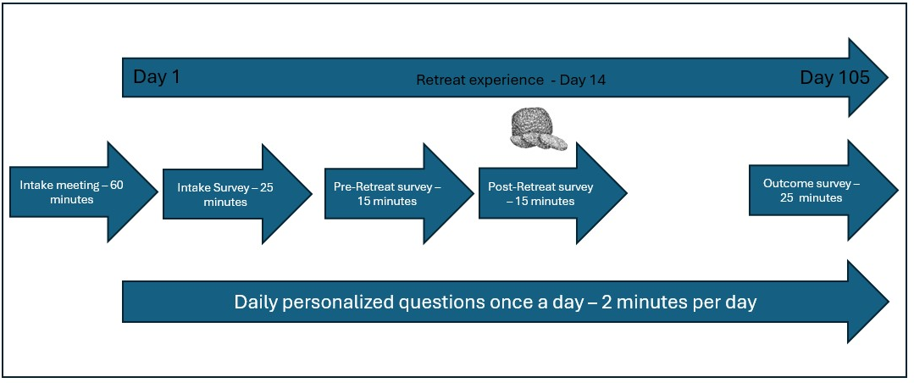
Benefits and risks

Taking part in the study can have pros and cons. We will list them below. Think about this carefully and talk to other people about it.

By participating in this study, you will significantly help the researchers to get more insight into the effects of magic truffles in a retreat setting, and personal change and transformation that may come after it and contribute to scientific progress.

Taking part in the study can have these cons:
- Taking part in the study will cost you time.

Compensation

There will not be a monetary compensation for participating in this study. As a compensation you will receive a t-shirt (see below for an example). Additionally, upon your request you will be provided with personalized network graphs (see below for examples) visualizing certain aspects of personal change and transformation you went through during the course of the study. In case of incomplete participation in this study, you will not be able to receive the t-shirt or the personalized network graphs.

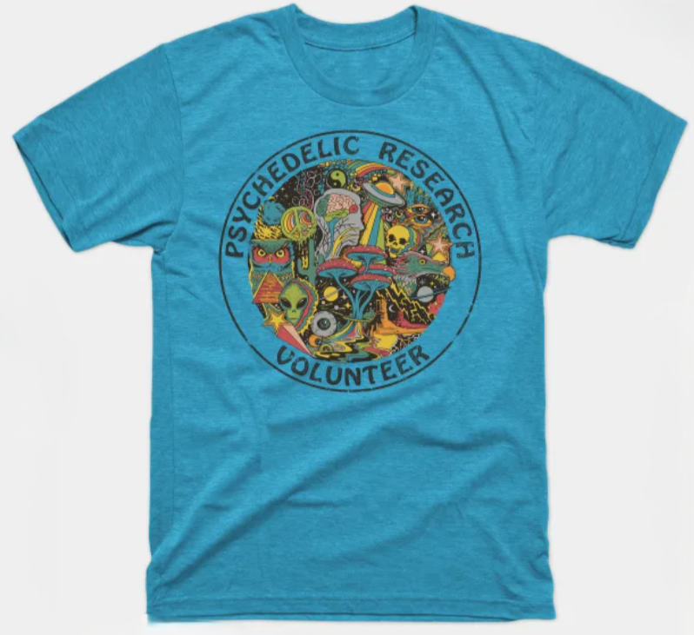

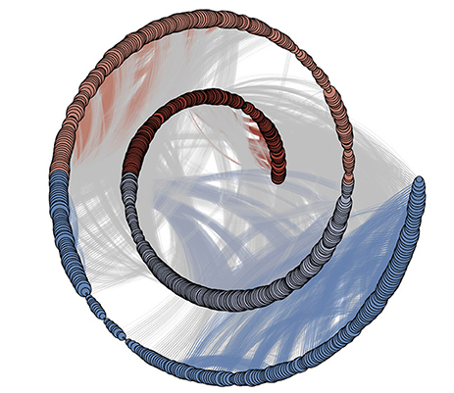
Figure 2 - A Recurrence network graph of change

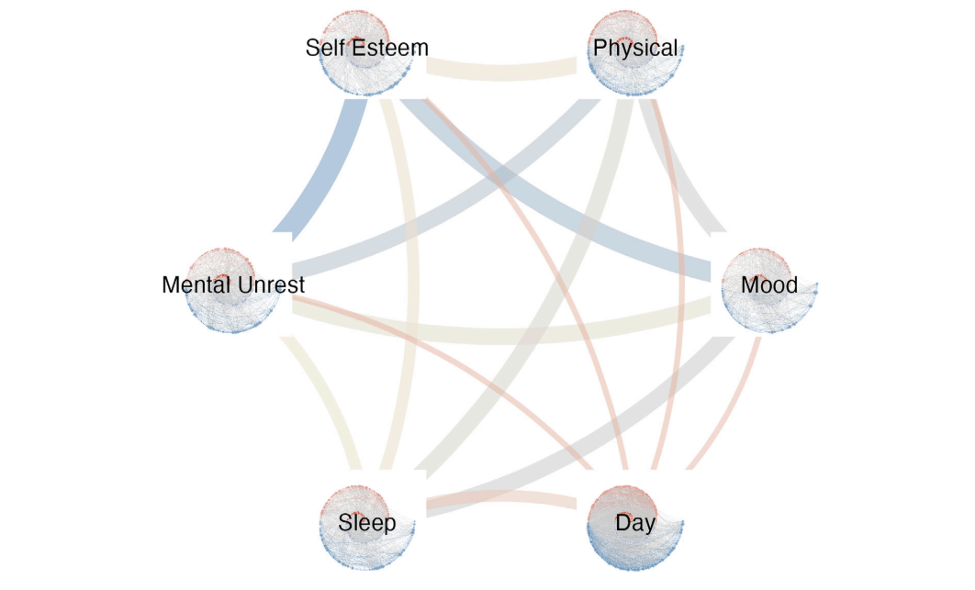

Figure 3- Multiplex Recurrence Network consisting of several networks of different categories of daily personalized questions

Confidentiality and privacy

All your data will be handled with strict confidentiality. For this study, we will collect data from questionnaires alone.

How do we protect your privacy?

To protect your privacy, your data will be stored, processed and published in a coded manner. This means we associate your data with a code rather than your personally-identifiable information, so nobody will be able to link the data to you. We save the key to the code in a physically-locked or password-protected location, accessible only to the researcher(s) in charge.

Furthermore, you are encouraged to use a pseudonym when signing up for the m-path app. This way your responses will not be able to linked to you during the data collection phase. At the end of the data collection phase, you will be asked what pseudonym you used in order to provide you with the personalized network graphs.

We store your data for 10 years. For the sake of transparency and open science, your anonymous/de-identified data will be made available to other interested researchers via accessible data repositories.

Can you withdraw your consent for the use of your data?

You can take back your consent for the use, storage, and publishing of your data within two weeks after your participation has ended.

For more information on data privacy and your rights, please check the European Union’s data privacy law, known as the General Data Protection Regulation (“GDPR”).

Contact information

If you have any questions before or after participating in this study, you can contact the research team via retreatESM.study@fsw.leidenuniv.nl, or the principal investigator: Michiel van Elk (m.van.elk@fsw.leidenuniv.nl).

You can also contact the research team or the principal investigator if you have a complaint. If you prefer not to do so, you can contact the Contact point for research participants at the Faculty of Social Sciences of Leiden University: Contactpuntparticipanten@fsw.leidenuniv.nl

If you have any questions or complaints about your privacy or the processing of your personal data, you can contact the privacy officer of Leiden University: privacy@bb.leidenuniv.nl

Kind regards,

Prof. Michiel van Elk
MSc. Huseyin Beykoylu

